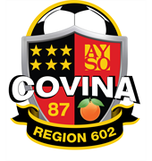

**AYSO REGION 602**

**REFUND POLICY**

If a decision is made after registration that your child will not be participating in the season, a refund can be requested. **The withdrawal of your player(s) and a refund request form must be filled out and mailed to the registrar at the address indicated below or emailed to the registrar**. All refunds must be post marked by August 1st of that registration year. Requests after August 1st will be reviewed for approval of refund.

**A refund of fees do not include the National Fee of $25.00**. This is non-refundable. The amount of the refund will be issued back to the person whose name appears on the on-line registration form. After August 1st any refund requests received will be reviewed and a pro-rata refund may be calculated depending upon the date of the request.

**The request form is located on our site under REFUNDS**. **Please fill this out as accurately as possible. Please allow up to 4 - 8 weeks for the refund to be processed**. You can email the form to the Registrar or to verify receipt of your refund request.

Email Kim Flink at [ayso602registar@gmail.com](mailto:ayso602registar@gmail.com) for any questions or status of your request.

Mail request to:

AYSO Region 602

Attn: REGISTRAR

PO Box 1859

Covina, CA 91723